Here are the characteristics that your file must exhibit:
- The file format is a *.dxf format.
- The file shows the outline of the link that will be cut on the laser-cutter.
- The file uses inches as the unit of length.
- The scale is 1:1.
- The file contains only the link, for example there is no title block or reference planes.

Here are instructions for creating your file from SolidEdge:
- Create your part in SolidEdge using the Normeng.Par template (this ensures that your part is created using inches rather than mm)
- Hide the reference planes
- Create the drawing using Normeng.dft template
- Place only a single view that shows the outline of the link (see below) 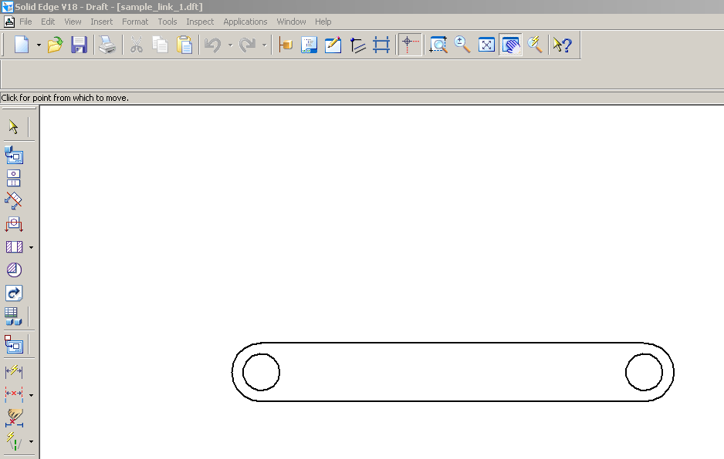
- Ensure the scale for the view is 1:1 (Pass the mouse over the view and then right-click on the red outline. Then under the General Tab select a Scale Value of 1.0.)
- Select Background Sheet from the View pull-down menu
- Select the appropriate background sheet from tabs shown below the drawing (e.g. “D-Sheet”)
- Highlight and delete the background sheet
- Return to “Sheet 1” that should now just show the front view of the part
- Save as a .dxf file with the appropriate file name

