RESound: Interactive Sound Rendering for Dynamic Virtual Environments

ABSTRACT
This paper presents an algorithm for simulating sound geometric propagation. The algorithm supports several propagation types: specular reflections, diffuse reflections, diffraction. The simulation is complimented with reverberation estimation. The propagation simulation is based on ray tracing and supports fully dynamic scenes.

INTRODUCTION
The main features are:
-Propagation of specular, diffuse, and diffraction sound
-Reverb estimation
-Dynamic sources, receivers, and scenes
-Ray based algorithm is parallel friendly

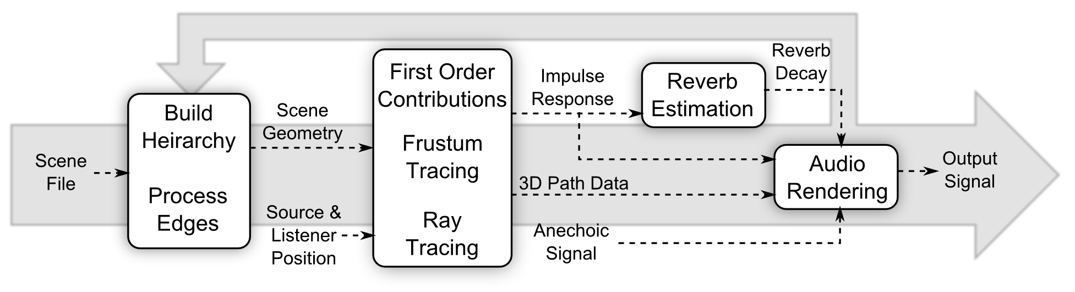

PREVIOUS WORK + MODELING
When a sound is generated in space, the wave propagates through the environment, eventually arriving at a receiver. Various simulations can model this process. Numerical simulation of the propagation is best, but the solvers are slow and only work on static scenes. Geometric methods are faster, but require extra work to get diffraction effects. diffuse reflections, and late reverberation.

PROPAGATION + REVERBERATION
The compute the specular paths, a frustum tracing algorithm is used. Frusta are traced from the source into the scene, similar to ray tracing. If a frustum hits an object, it is subdivided to increase propagation accuracy. If a frustum contains the receiver, the path from the source to the receiver through the frustum is found and recorded.
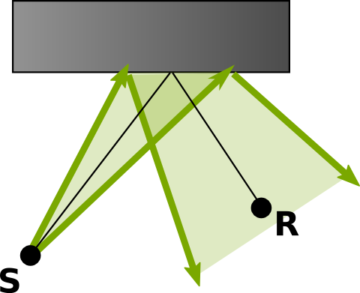

When sound hits and edge, it is diffracts around the edge. Whenever a frustum hits an edge, and diffraction frusta is created. The sound path is computed similar to specular paths, but with diffraction attenuation.
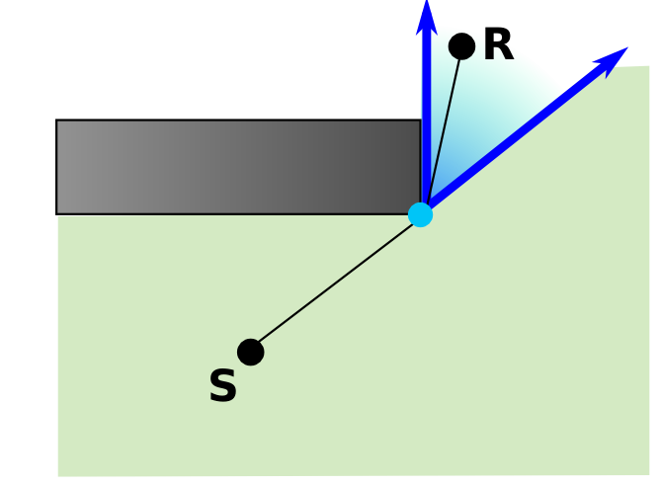

The diffuse contribution is modeled with a regular ray tracer. A single simulation is run for all frequency bands and the final response is scaled based on the materials encountered. The final diffuse response is collected in a histogram and converted to pressure values.
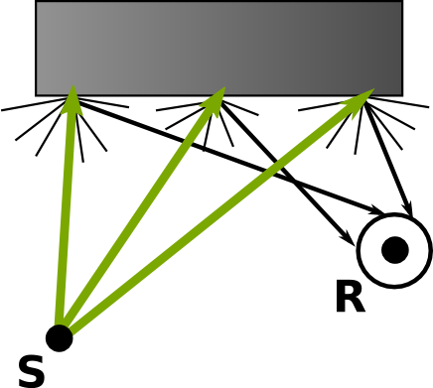

The energy and time data points in the response are fit with a linear least-squares line in log space. This line is used to estimate the reverberation decay.

AUDIO RENDERING
The specular, diffraction, and diffuse signals are computed based on path properties and combined into a single signal. Crossfading is used to avoid artifacts form dynamic motion. The reverberation is added in using an XAudio effect.

PERFORMANCE + QUALITY AND LIMITATIONS + CONCLUSION
The system was tested on a 2.66 Ghz PC. A single thread renders a single recursion of specular and diffraction frusta. Specular and diffraction rendering for up to 3 orders is run on 7 threads. Diffuse tracing is conducted on 7 threads.

Rendering times for this setup were in the range of 0.5 - 1 second on medium sized scenes. The propagation methods resulted in some error compared to more accurate methods. The amount of error varied based on simulation parameters.

